Geometry Logical Proofs

Definition
# Source: AI Source: Provided by: [Data Path: Persons Table -> ID Column: 1, Name_En Column: Motasem Essam] -> From: [ChatGPT] on [7/25/2026]
Geometry Logical Proofs are systematic mathematical arguments used to establish that a geometric statement is necessarily true by connecting given information to a conclusion through valid logical reasoning.
A geometric proof follows:
$$\boxed{\text{Given Information}→\text{Logical Reasoning}→\text{Conclusion}}$$
The purpose of a logical proof is not simply to show that a statement appears true in a diagram, but to demonstrate why it must be true.

Fundamental Concept
# Source: AI Source: Provided by: [Data Path: Persons Table -> ID Column: 1, Name_En Column: Motasem Essam] -> From: [ChatGPT] on [7/25/2026]
A geometry logical proof is based on a sequence of statements in which each statement follows from:
- Given information.
- Definitions.
- Axioms.
- Postulates.
- Previously established theorems.
- Properties of equality.
- Algebraic properties.
- Previously proven statements.
The general structure is:
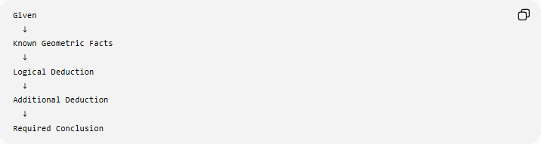
Given
↓
Known Geometric Facts
↓
Logical Deduction
↓
Additional Deduction
↓
Required Conclusion

Components of a Logical Proof

1. Given
# Source: AI Source: Provided by: [Data Path: Persons Table -> ID Column: 1, Name_En Column: Motasem Essam] -> From: [ChatGPT] on [7/25/2026]
The given information consists of facts explicitly provided by the problem.
Examples:
$$AB=AC \\ l∥m \\ M\text{ is the midpoint of }\overset{‾}{AB} \\ ∠A={90}^{∘}$$

2. Goal
# Source: AI Source: Provided by: [Data Path: Persons Table -> ID Column: 1, Name_En Column: Motasem Essam] -> From: [ChatGPT] on [7/25/2026]
The goal is the statement that must be proved.
For example:
$$\boxed{∠B=∠C}$$
or:
$$\boxed{AB∥CD}$$
The goal is sometimes called the conclusion or statement to prove.

3. Reasoning
# Source: AI Source: Provided by: [Data Path: Persons Table -> ID Column: 1, Name_En Column: Motasem Essam] -> From: [ChatGPT] on [7/25/2026]
Reasoning connects the given information to the conclusion.
Common reasons include:
- Definition of midpoint.
- Definition of perpendicular lines.
- Definition of parallel lines.
- Vertical Angles Theorem.
- Linear Pair Postulate.
- Triangle Sum Theorem.
- Isosceles Triangle Theorem.
- Congruence theorems.
- Similarity theorems.
- Algebraic properties.

Basic Logical Structure
# Source: AI Source: Provided by: [Data Path: Persons Table -> ID Column: 1, Name_En Column: Motasem Essam] -> From: [ChatGPT] on [7/25/2026]
A simple geometry proof can be represented as:
$$\boxed{G_{1},G_{2},…,G_{n}→S_{1}→S_{2}→⋯→C}$$
where:
- $G$= given information.
- $S$= derived statement.
- $C$= conclusion.
Every step must be logically justified.

Types of Geometry Logical Proof
# Source: AI Source: Provided by: [Data Path: Persons Table -> ID Column: 1, Name_En Column: Motasem Essam] -> From: [ChatGPT] on [7/25/2026]
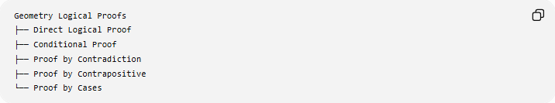
Geometry Logical Proofs
├── Direct Logical Proof
├── Conditional Proof
├── Proof by Contradiction
├── Proof by Contrapositive
└── Proof by Cases
These are logical methods rather than presentation formats.

1. Direct Logical Proof
# Source: AI Source: Provided by: [Data Path: Persons Table -> ID Column: 1, Name_En Column: Motasem Essam] -> From: [ChatGPT] on [7/25/2026]
Definition
A direct proof begins with the given information and proceeds logically until the required conclusion is reached.
Structure
$$\boxed{\text{Given}→\text{Known Facts}→\text{Logical Deductions}→\text{Conclusion}}$$
Example
Given:
$$AB=AC$$
in $△ABC$.
Since two sides are equal:
$$△ABC$$
is isosceles.
By the Isosceles Triangle Theorem:
$$\boxed{∠B=∠C}$$

2. Conditional Logical Proof
# Source: AI Source: Provided by: [Data Path: Persons Table -> ID Column: 1, Name_En Column: Motasem Essam] -> From: [ChatGPT] on [7/25/2026]
Many geometry statements have the form:
$$\boxed{P→Q}$$
meaning:
If $P$is true, then $Q$must be true.
For example:
If two lines are perpendicular, then they form right angles.
Symbolically:
$$l⊥m→∠={90}^{∘}$$
A conditional proof establishes the conclusion by assuming the condition $P$and logically deriving $Q$.

3. Proof by Contradiction
# Source: AI Source: Provided by: [Data Path: Persons Table -> ID Column: 1, Name_En Column: Motasem Essam] -> From: [ChatGPT] on [7/25/2026]
Definition
Proof by contradiction assumes that the desired conclusion is false and then shows that this assumption leads to an impossibility.
Structure
$$\boxed{\text{Assume }¬P→\text{Logical Consequences}→\text{Contradiction}→P}$$
The contradiction may conflict with:
- A given condition.
- A definition.
- An axiom.
- A theorem.
- A previously established fact.
Example Structure
To prove:
$$P$$
assume:
$$¬P$$
Then derive:
$$⊥$$
Therefore:
$$\boxed{P}$$

4. Proof by Contrapositive
# Source: AI Source: Provided by: [Data Path: Persons Table -> ID Column: 1, Name_En Column: Motasem Essam] -> From: [ChatGPT] on [7/25/2026]
For a conditional statement:
$$P→Q$$
the contrapositive is:
$$\boxed{¬Q→¬P}$$
A conditional statement and its contrapositive are logically equivalent.
Example
Original:
If a triangle is equilateral, then it is isosceles.
$$\text{Equilateral}→\text{Isosceles}$$
Contrapositive:
If a triangle is not isosceles, then it is not equilateral.
$$\boxed{\text{Not Isosceles}→\text{Not Equilateral}}$$

5. Proof by Cases
# Source: AI Source: Provided by: [Data Path: Persons Table -> ID Column: 1, Name_En Column: Motasem Essam] -> From: [ChatGPT] on [7/25/2026]
Definition
Proof by cases divides the possible configurations into separate cases and proves the desired statement in every applicable case.
Structure
$$\boxed{\text{Case 1}→P} \\ \boxed{\text{Case 2}→P} \\ \boxed{\text{Case 3}→P}$$
Therefore:
$$\boxed{P}$$
Example
A geometric argument may consider:
- Acute triangle.
- Right triangle.
- Obtuse triangle.
If the same conclusion is established for all three cases, the result holds for every triangle covered by the cases.

Logical Rules Used in Geometry

1. Transitive Property
# Source: AI Source: Provided by: [Data Path: Persons Table -> ID Column: 1, Name_En Column: Motasem Essam] -> From: [ChatGPT] on [7/25/2026]
If:
$$a=b$$
and:
$$b=c$$
then:
$$\boxed{a=c}$$
Geometric example:
$$AB=CD$$
and:
$$CD=EF$$
therefore:
$$\boxed{AB=EF}$$

2. Substitution Property
# Source: AI Source: Provided by: [Data Path: Persons Table -> ID Column: 1, Name_En Column: Motasem Essam] -> From: [ChatGPT] on [7/25/2026]
If:
$$a=b$$
then $b$can replace $a$in an equation or relationship.
Example:
$$AB=CD$$
and:
$$CD=10$$
therefore:
$$\boxed{AB=10}$$

3. Addition Property of Equality
# Source: AI Source: Provided by: [Data Path: Persons Table -> ID Column: 1, Name_En Column: Motasem Essam] -> From: [ChatGPT] on [7/25/2026]
If:
$$a=b$$
then:
$$\boxed{a+c=b+c}$$
Example:
$$AB=CD$$
Therefore:
$$AB+BC=CD+BC$$

4. Subtraction Property of Equality
# Source: AI Source: Provided by: [Data Path: Persons Table -> ID Column: 1, Name_En Column: Motasem Essam] -> From: [ChatGPT] on [7/25/2026]
If:
$$a=b$$
then:
$$\boxed{a-c=b-c}$$

5. Multiplication Property of Equality
# Source: AI Source: Provided by: [Data Path: Persons Table -> ID Column: 1, Name_En Column: Motasem Essam] -> From: [ChatGPT] on [7/25/2026]
If:
$$a=b$$
then:
$$\boxed{ca=cb}$$

6. Division Property of Equality
# Source: AI Source: Provided by: [Data Path: Persons Table -> ID Column: 1, Name_En Column: Motasem Essam] -> From: [ChatGPT] on [7/25/2026]
If:
$$a=b, c≠0$$
then:
$$\boxed{\frac{a}{c}=\frac{b}{c}}$$

Logical Relations in Geometry

Reflexive Property
# Source: AI Source: Provided by: [Data Path: Persons Table -> ID Column: 1, Name_En Column: Motasem Essam] -> From: [ChatGPT] on [7/25/2026]
Every geometric quantity is equal or congruent to itself:
$$\boxed{AB=AB}$$
and:
$$\boxed{∠A≅∠A}$$
This property is especially important in triangle congruence proofs.

Symmetric Property
# Source: AI Source: Provided by: [Data Path: Persons Table -> ID Column: 1, Name_En Column: Motasem Essam] -> From: [ChatGPT] on [7/25/2026]
If:
$$a=b$$
then:
$$\boxed{b=a}$$
Geometrically:
$$AB=CD⇒CD=AB$$

Transitive Property
# Source: AI Source: Provided by: [Data Path: Persons Table -> ID Column: 1, Name_En Column: Motasem Essam] -> From: [ChatGPT] on [7/25/2026]
If:
$$a=b$$
and:
$$b=c$$
then:
$$\boxed{a=c}$$

Using Definitions in Logical Proofs
Definitions are often the most direct logical tools.

Midpoint
# Source: AI Source: Provided by: [Data Path: Persons Table -> ID Column: 1, Name_En Column: Motasem Essam] -> From: [ChatGPT] on [7/25/2026]
If $M$is the midpoint of $\overset{‾}{AB}$, then:
$$\boxed{AM=MB}$$
and:
$$A,M,B$$
are collinear.

Perpendicular Lines
# Source: AI Source: Provided by: [Data Path: Persons Table -> ID Column: 1, Name_En Column: Motasem Essam] -> From: [ChatGPT] on [7/25/2026]
If:
$$l⊥m$$
then the angles formed at their intersection are right angles:
$$\boxed{∠={90}^{∘}}$$

Parallel Lines
# Source: AI Source: Provided by: [Data Path: Persons Table -> ID Column: 1, Name_En Column: Motasem Essam] -> From: [ChatGPT] on [7/25/2026]
If:
$$l∥m$$
then transversal angle relationships can be applied.
For example:
$$\boxed{\text{Corresponding angles are congruent}}$$

Angle Bisector
# Source: AI Source: Provided by: [Data Path: Persons Table -> ID Column: 1, Name_En Column: Motasem Essam] -> From: [ChatGPT] on [7/25/2026]
If ray $\vec{BD}$bisects $∠ABC$, then:
$$\boxed{∠ABD=∠DBC}$$

Segment Bisector
# Source: AI Source: Provided by: [Data Path: Persons Table -> ID Column: 1, Name_En Column: Motasem Essam] -> From: [ChatGPT] on [7/25/2026]
If a line or ray bisects $\overset{‾}{AB}$, then it divides the segment into two congruent segments:
$$\boxed{AM=MB}$$

Logical Proof Using Triangle Congruence
# Source: AI Source: Provided by: [Data Path: Persons Table -> ID Column: 1, Name_En Column: Motasem Essam] -> From: [ChatGPT] on [7/25/2026]
Triangle congruence is one of the most important logical structures in geometry.
Suppose:
$$AB=DE \\ BC=EF$$
and:
$$∠B=∠E$$
Then:
$$\boxed{△ABC≅△DEF}$$
by SAS.
After establishing congruence, corresponding parts can be used.
For example:
$$\boxed{AC=DF}$$
This follows from CPCTC:
Corresponding Parts of Congruent Triangles are Congruent.

Logical Proof Using Similarity
# Source: AI Source: Provided by: [Data Path: Persons Table -> ID Column: 1, Name_En Column: Motasem Essam] -> From: [ChatGPT] on [7/25/2026]
If:
$$△ABC∼△DEF$$
then corresponding angles are congruent and corresponding sides are proportional:
$$\boxed{\frac{AB}{DE}=\frac{BC}{EF}=\frac{AC}{DF}}$$
This can be used to logically establish unknown lengths or proportional relationships.

Logical Proof Using Angle Relationships
# Source: AI Source: Provided by: [Data Path: Persons Table -> ID Column: 1, Name_En Column: Motasem Essam] -> From: [ChatGPT] on [7/25/2026]
Important angle relationships include:
Vertical Angles
$$\boxed{∠1≅∠2}$$
Linear Pair
$$\boxed{∠1+∠2={180}^{∘}}$$
Complementary Angles
$$\boxed{∠1+∠2={90}^{∘}}$$
Supplementary Angles
$$\boxed{∠1+∠2={180}^{∘}}$$
Triangle Angle Sum
$$\boxed{A+B+C={180}^{∘}}$$
These relationships frequently form intermediate steps in a proof.

Logical Proof Using Parallel Lines
# Source: AI Source: Provided by: [Data Path: Persons Table -> ID Column: 1, Name_En Column: Motasem Essam] -> From: [ChatGPT] on [7/25/2026]
When two parallel lines are cut by a transversal:
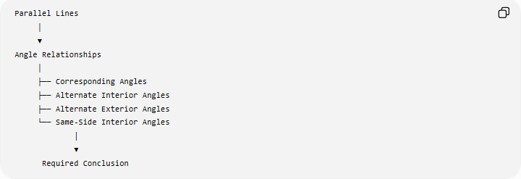
Parallel Lines
│
▼
Angle Relationships
│
├── Corresponding Angles
├── Alternate Interior Angles
├── Alternate Exterior Angles
└── Same-Side Interior Angles
│
▼
Required Conclusion
For example:
$$l∥m$$
implies corresponding angles are congruent.
Conversely, certain angle relationships can be used to prove:
$$\boxed{l∥m}$$

Logical Proof Using Algebra
# Source: AI Source: Provided by: [Data Path: Persons Table -> ID Column: 1, Name_En Column: Motasem Essam] -> From: [ChatGPT] on [7/25/2026]
Geometry often requires algebraic deductions.
Suppose:
$$AB=3x+5$$
and:
$$CD=2x+10$$
and:
$$AB=CD$$
Then:
$$3x+5=2x+10$$
Subtract $2x$:
$$x+5=10$$
Subtract $5$:
$$\boxed{x=5}$$
Thus logical geometry proofs often combine geometric reasoning with algebra.

Logical Proof Using Coordinate Geometry
# Source: AI Source: Provided by: [Data Path: Persons Table -> ID Column: 1, Name_En Column: Motasem Essam] -> From: [ChatGPT] on [7/25/2026]
Coordinates allow geometric statements to be translated into algebraic relationships.
For example, to prove that two segments have equal lengths:
$$AB=\sqrt{{\left(x_{B}-x_{A}\right)}^{2}+{\left(y_{B}-y_{A}\right)}^{2}}$$
and:
$$CD=\sqrt{{\left(x_{D}-x_{C}\right)}^{2}+{\left(y_{D}-y_{C}\right)}^{2}}$$
If:
$$AB=CD$$
then the segments are congruent.
Similarly, slopes can establish parallelism and perpendicularity.

Logical Proof Using Transformations
# Source: AI Source: Provided by: [Data Path: Persons Table -> ID Column: 1, Name_En Column: Motasem Essam] -> From: [ChatGPT] on [7/25/2026]
Transformations can establish relationships by examining what is preserved.
An isometry satisfies:
$$\boxed{d\left(T , \left(P\right)T\left(Q\right)\right)=d\left(P , Q\right)}$$
Therefore, a transformation-based argument can establish congruence when one figure maps exactly onto another.
Similarity transformations satisfy:
$$\boxed{d\left(T , \left(P\right)T\left(Q\right)\right)=k d\left(P , Q\right)}$$
so corresponding lengths are proportional.

Logical Proof Using Loci
# Source: AI Source: Provided by: [Data Path: Persons Table -> ID Column: 1, Name_En Column: Motasem Essam] -> From: [ChatGPT] on [7/25/2026]
A locus provides a logical way to characterize points satisfying a condition.
For example:
The set of all points equidistant from $A$and $B$is the perpendicular bisector of $\overset{‾}{AB}$.
Thus:
$$PA=PB$$
implies:
$$\boxed{P\text{ lies on the perpendicular bisector of }\overset{‾}{AB}}$$
This can be used in proofs involving:
- Perpendicular bisectors.
- Circumcenters.
- Angle bisectors.
- Incircles.
- Circumcircles.

Example of a Complete Logical Proof
# Source: AI Source: Provided by: [Data Path: Persons Table -> ID Column: 1, Name_En Column: Motasem Essam] -> From: [ChatGPT] on [7/25/2026]
Given
In $△ABC$:
$$AB=AC$$
Prove
$$∠B=∠C$$
Logical Reasoning
- $AB=AC$.
Given
- $△ABC$has two congruent sides.
Definition of an isosceles triangle
- The angles opposite congruent sides are congruent.
Isosceles Triangle Theorem
- $∠B=∠C$.
Conclusion
Therefore:
$$\boxed{∠B=∠C}$$

Logical Proof vs Visual Evidence
# Source: AI Source: Provided by: [Data Path: Persons Table -> ID Column: 1, Name_En Column: Motasem Essam] -> From: [ChatGPT] on [7/25/2026]
A diagram can help identify relationships, but its appearance does not establish them.
For example, two segments may look equal:
$$AB≈CD$$
but visual appearance does not prove:
$$AB=CD$$
Likewise, two lines may look parallel without being mathematically parallel.
Therefore:
$$\boxed{\text{Diagram}+\text{Reasoning}≠\text{Diagram Alone}}$$
A valid proof requires logical justification.

Logical Proof vs Measurement
# Source: AI Source: Provided by: [Data Path: Persons Table -> ID Column: 1, Name_En Column: Motasem Essam] -> From: [ChatGPT] on [7/25/2026]
Measurement can suggest a relationship:
$$∠A≈{60}^{∘}$$
but exact geometry requires a reason that establishes:
$$\boxed{∠A={60}^{∘}}$$
Thus:
$$\boxed{\text{Measurement provides evidence; proof provides certainty.}}$$

Structure of a Geometry Logical Proof
# Source: AI Source: Provided by: [Data Path: Persons Table -> ID Column: 1, Name_En Column: Motasem Essam] -> From: [ChatGPT] on [7/25/2026]
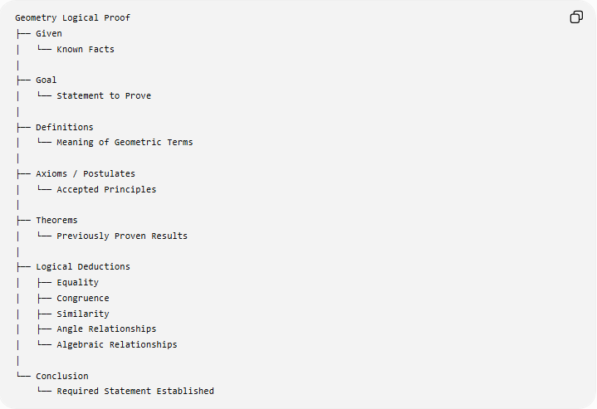
Geometry Logical Proof
├── Given
│ └── Known Facts
│
├── Goal
│ └── Statement to Prove
│
├── Definitions
│ └── Meaning of Geometric Terms
│
├── Axioms / Postulates
│ └── Accepted Principles
│
├── Theorems
│ └── Previously Proven Results
│
├── Logical Deductions
│ ├── Equality
│ ├── Congruence
│ ├── Similarity
│ ├── Angle Relationships
│ └── Algebraic Relationships
│
└── Conclusion
└── Required Statement Established

Classification
# Source: AI Source: Provided by: [Data Path: Persons Table -> ID Column: 1, Name_En Column: Motasem Essam] -> From: [ChatGPT] on [7/25/2026]
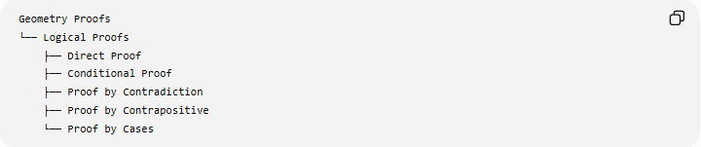
Geometry Proofs
└── Logical Proofs
├── Direct Proof
├── Conditional Proof
├── Proof by Contradiction
├── Proof by Contrapositive
└── Proof by Cases
Logical proofs can also use different geometric frameworks:
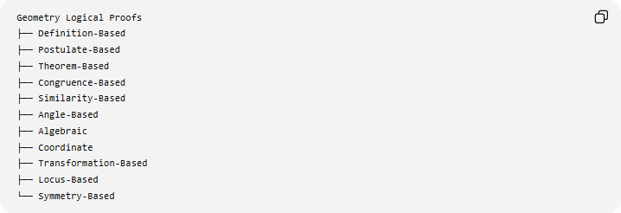
Geometry Logical Proofs
├── Definition-Based
├── Postulate-Based
├── Theorem-Based
├── Congruence-Based
├── Similarity-Based
├── Angle-Based
├── Algebraic
├── Coordinate
├── Transformation-Based
├── Locus-Based
└── Symmetry-Based
These two classifications describe different aspects of a proof. For example, a proof can be a direct logical proof using triangle congruence.

Key Points
# Source: AI Source: Provided by: [Data Path: Persons Table -> ID Column: 1, Name_En Column: Motasem Essam] -> From: [ChatGPT] on [7/25/2026]
- A geometry logical proof establishes a geometric statement through valid reasoning.
- Its fundamental structure is:
$$\boxed{\text{Given}→\text{Reasoning}→\text{Conclusion}}$$
- The principal logical methods are:
  - Direct proof.
  - Conditional proof.
  - Proof by contradiction.
  - Proof by contrapositive.
  - Proof by cases.
- Definitions, axioms, postulates, and theorems provide the justification for individual steps.
- Equality properties such as reflexive, symmetric, and transitive properties are frequently used.
- Triangle congruence and similarity are major geometric proof frameworks.
- Algebra and coordinate geometry can provide rigorous mathematical reasoning.
- A diagram or measurement alone does not constitute a logical proof.

Conclusion
# Source: AI Source: Provided by: [Data Path: Persons Table -> ID Column: 1, Name_En Column: Motasem Essam] -> From: [ChatGPT] on [7/25/2026]
Geometry Logical Proofs provide the logical foundation for proving geometric statements. They transform given geometric information into a necessary conclusion through definitions, postulates, theorems, algebraic relationships, and valid logical deductions. The central principle is that every important step must follow from something already known or established, making the conclusion logically necessary rather than merely visually convincing.

